- Click on the course you want to import content into (e.g. your new teaching course)
- Click【 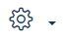】>【More】
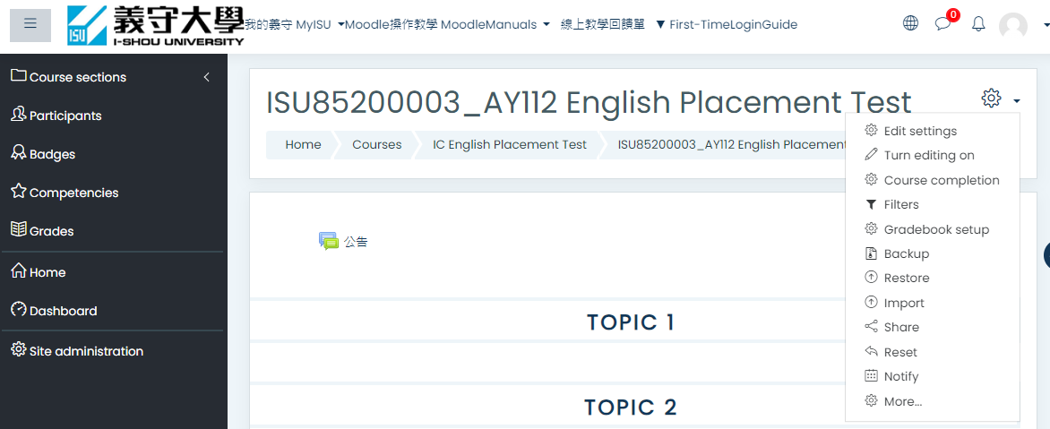
- 【Course administration】, click on【Import】
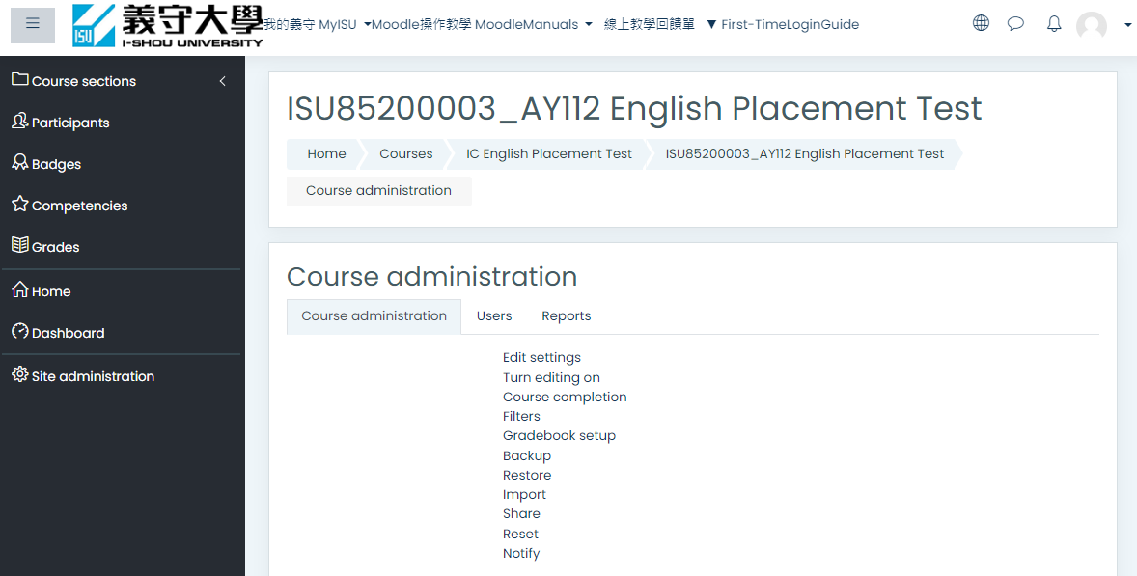

- Select the course you want to import the data from. Click on Continue to proceed to next step. If the list of course is too long, you may use the search function to narrow down the results.
For example, search for "English Placement Test," and click on the old course you want to select.
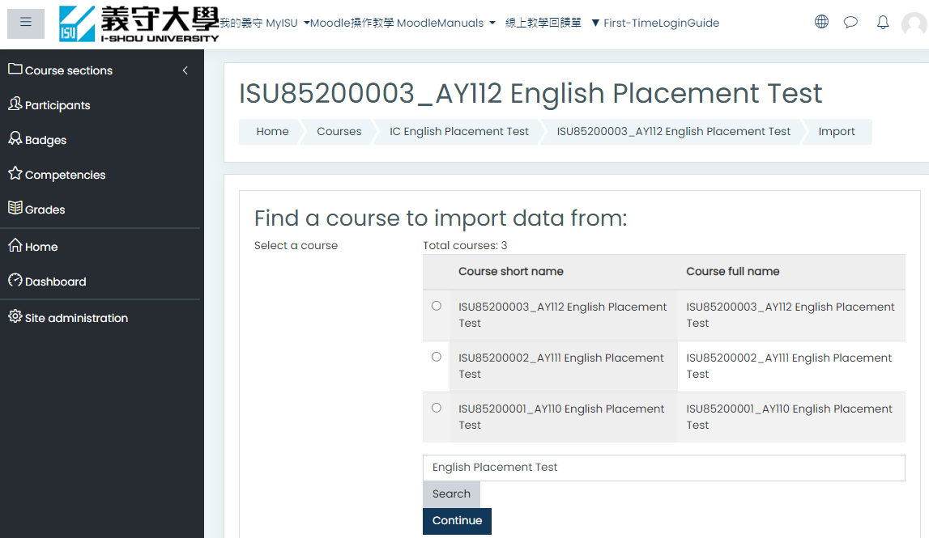

- Click 【Next】
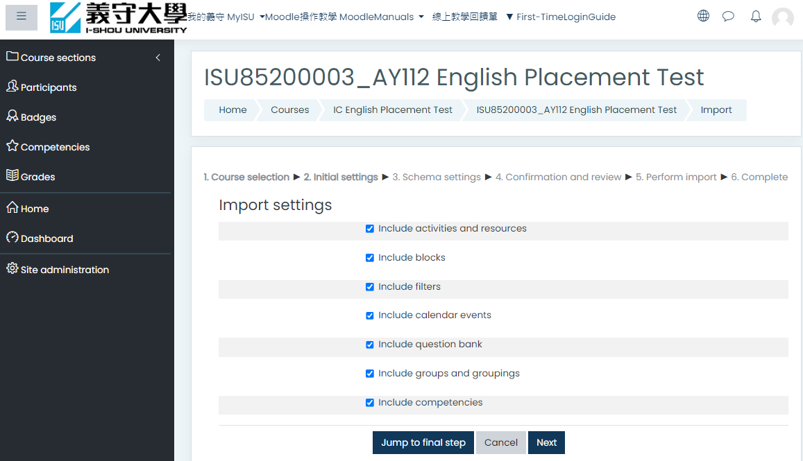

- On the Schema settings page you will select the item(s) to copy. By default, all sections and the items in them are selected. Click None (at top) to deselect all Sections and the activities and resources they contain
select the item(s) to copy >【next】
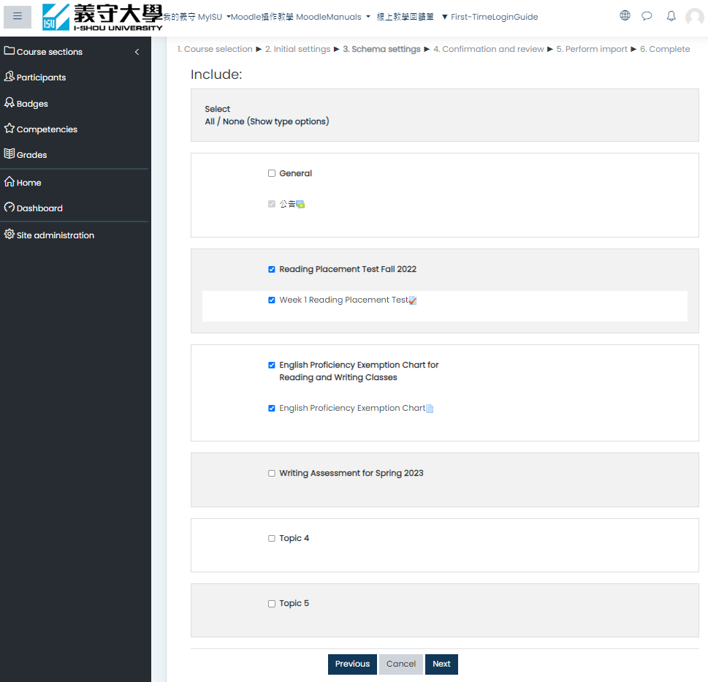

- On the Confirmation and Review page, review all the settings. Once everything is confirmed, click on 【Perform import】.
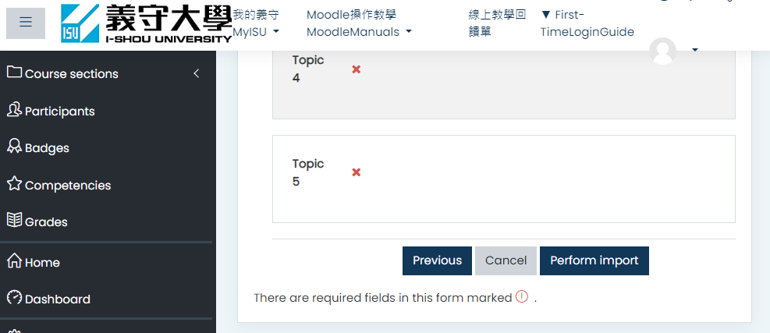
- A progress bar will be displayed showing the backup progress. This may take a while depending on the size of your course data.
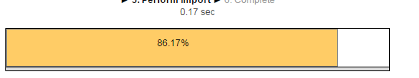
- A message will be displayed upon completion of the import process. Click Continue to go back to the course view
Click 【Continue】
You will be returned to your course page with the Section containing the copied item(s) added. As needed, move each copied item into the Section where you want it to appear

